**Education Welfare Request for support**

**Defence Childrens Services – Welfare & Social Work Team**

|  |  |
| --- | --- |
| **I am requesting support for:** | |
| **My childs Attendance at school** | **To report my child as not attending school** |

|  |  |  |  |
| --- | --- | --- | --- |
| **Name of child/ren** |  | **School Setting** |  |
| **DOB + Age** |  | **Year Group** |  |
| **Parent/Carer Name** |  | **Parent/Carer Contact Details** |  |
| **School lead Name** |  | **School lead Contact Details** |  |
| **Date completed** |  | | |

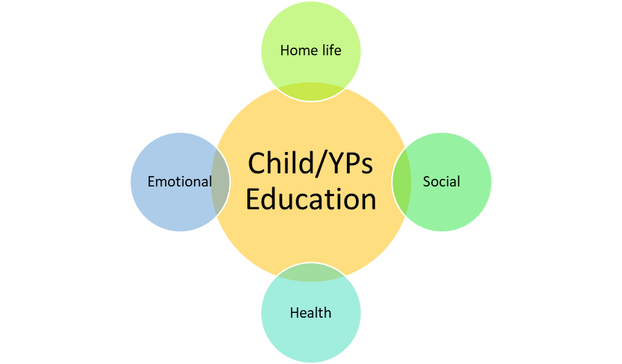

|  |  |  |  |
| --- | --- | --- | --- |
| **Are they currently attending school?** | *If so, do you know their rough attendance percentage?* | **Does the school know you would like support at this time?** |  |
| **Any other Professionals currently involved with your family:** |  | **Any identified additional needs including SEND?:** |  |
| **Summary of situation/request for support:** | *Please provide as much detail here as you feel able.* | | |

|  |  |
| --- | --- |
| **What is your desired outcome for your child/family?** |  |
| **What is your desired outcome for the school/setting?** |  |

On Submission of this self-referral, DCS will store yours and your family’s personal information in line with DCS Privacy Notice and MOD Privacy Notice. We will speak to your child/ren’s current school and any other professionals involved with your family in order to ensure you are receiving a joined-up support package. We may have to share personal information with other agencies in order to do this, but we will always seek to inform you before we do so. The only instance we would not inform you would be if we had a significant concern for your child/rens safety at which point we would report this to the social care provider within your location.

We aim to work alongside children and families and use strength-based approaches to support and empower change.

**Education Welfare + Social Work team**

|  |  |  |  |
| --- | --- | --- | --- |
| **Date received:** |  | **Date Triaged:** |  |
| **EWO allocation:** |  | | |
| **Contact made with referrer:** |  | | |
| **Support offered:** | Informal EWO support in person  Informal EWO support via Teams  Formal EWO support  Advice and guidance to school/setting  Other | | |